MACHINE LEARNING

ASSIGNMENT 3

NAME: DURGAM NAGA DEERAJ REDDY

USN: 22BTRAD013

Q. Load a dataset with (features of different scales) Boston Housing Dataset



CODE:

# DURGAM NAGA DEERAJ REDDY(22BTRAD013)

import pandas as pd

# Load the Boston Housing dataset

boston_data = pd.read_csv('HousingData.csv')

Q. Apply Min-Max scaling to dataset

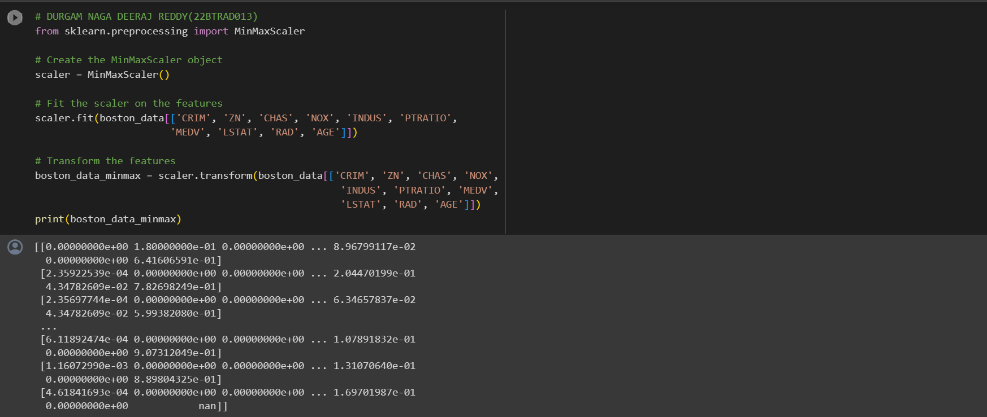

CODE:

# DURGAM NAGA DEERAJ REDDY(22BTRAD013)

from sklearn.preprocessing import MinMaxScaler

# Create the MinMaxScaler object

scaler = MinMaxScaler()

# Fit the scaler on the features

scaler.fit(boston_data[['CRIM', 'ZN', 'CHAS', 'NOX', 'INDUS', 'PTRATIO',

                       'MEDV', 'LSTAT', 'RAD', 'AGE']])

# Transform the features

boston_data_minmax = scaler.transform(boston_data[['CRIM', 'ZN', 'CHAS', 'NOX',

                                                    'INDUS', 'PTRATIO', 'MEDV',

                                                    'LSTAT', 'RAD', 'AGE']])

print(boston_data_minmax)

Q. Apply Standardization to dataset

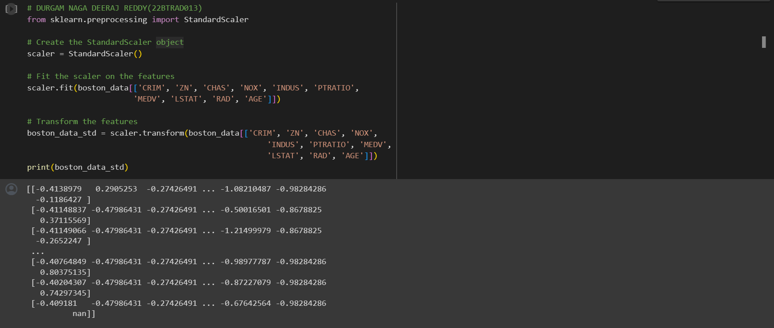

CODE:

# DURGAM NAGA DEERAJ REDDY(22BTRAD013)

from sklearn.preprocessing import StandardScaler

# Create the StandardScaler object

scaler = StandardScaler()

# Fit the scaler on the features

scaler.fit(boston_data[['CRIM', 'ZN', 'CHAS', 'NOX', 'INDUS', 'PTRATIO',

                       'MEDV', 'LSTAT', 'RAD', 'AGE']])

# Transform the features

boston_data_std = scaler.transform(boston_data[['CRIM', 'ZN', 'CHAS', 'NOX',

                                                    'INDUS', 'PTRATIO', 'MEDV',

                                                    'LSTAT', 'RAD', 'AGE']])

print(boston_data_std)

Q. Apply Robust scaling to the dataset

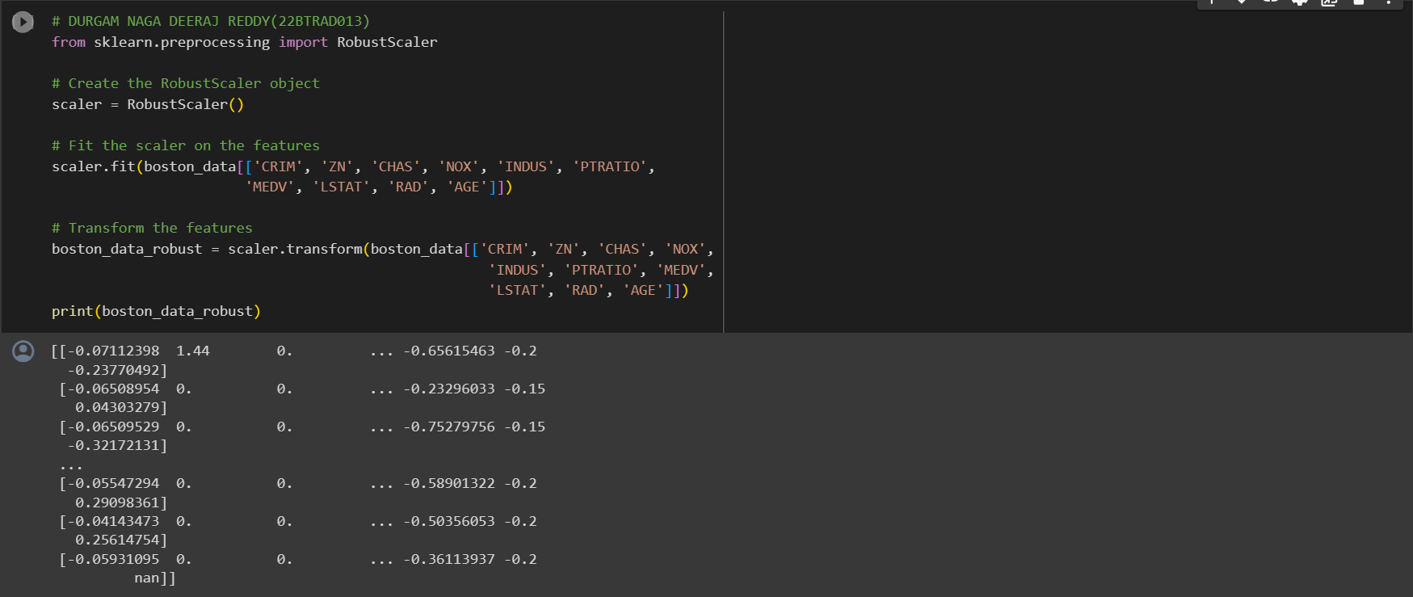

CODE:

# DURGAM NAGA DEERAJ REDDY(22BTRAD013)

from sklearn.preprocessing import RobustScaler

# Create the RobustScaler object

scaler = RobustScaler()

# Fit the scaler on the features

scaler.fit(boston_data[['CRIM', 'ZN', 'CHAS', 'NOX', 'INDUS', 'PTRATIO',

                       'MEDV', 'LSTAT', 'RAD', 'AGE']])

# Transform the features

boston_data_robust = scaler.transform(boston_data[['CRIM', 'ZN', 'CHAS', 'NOX',

                                                    'INDUS', 'PTRATIO', 'MEDV',

                                                    'LSTAT', 'RAD', 'AGE']])

print(boston_data_robust)

Q. Assess the impact of scaling on the dataset

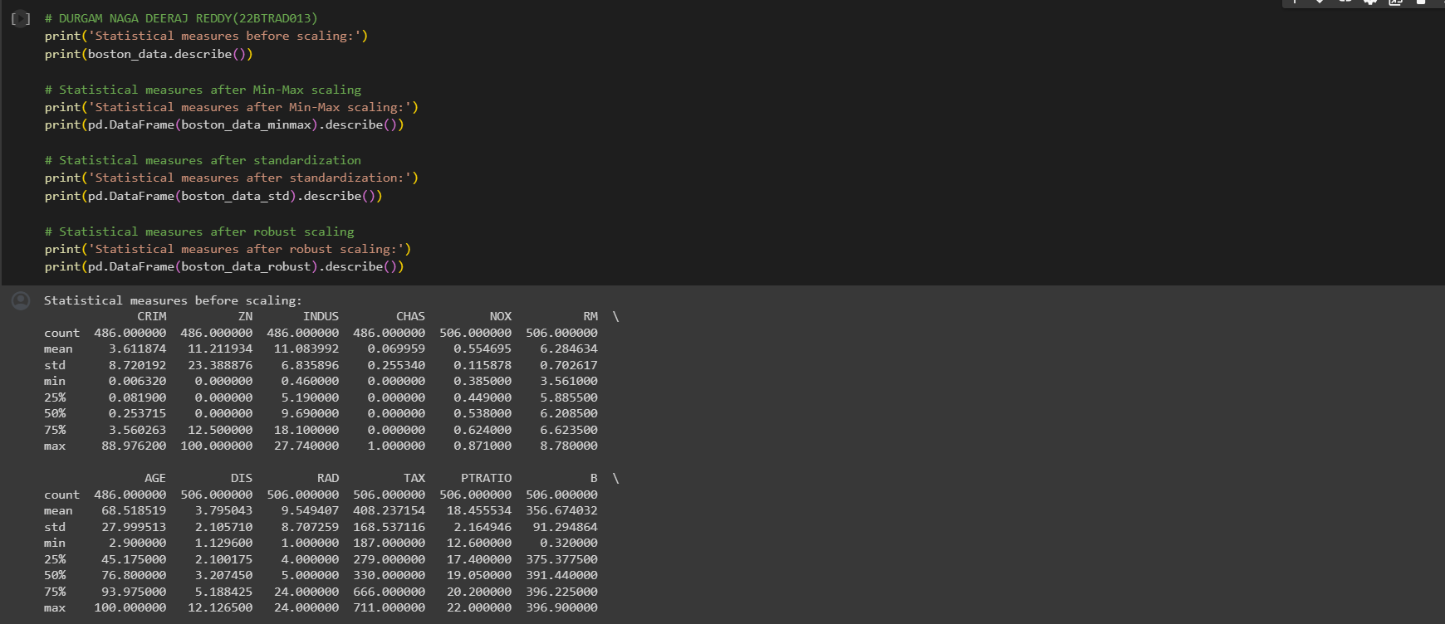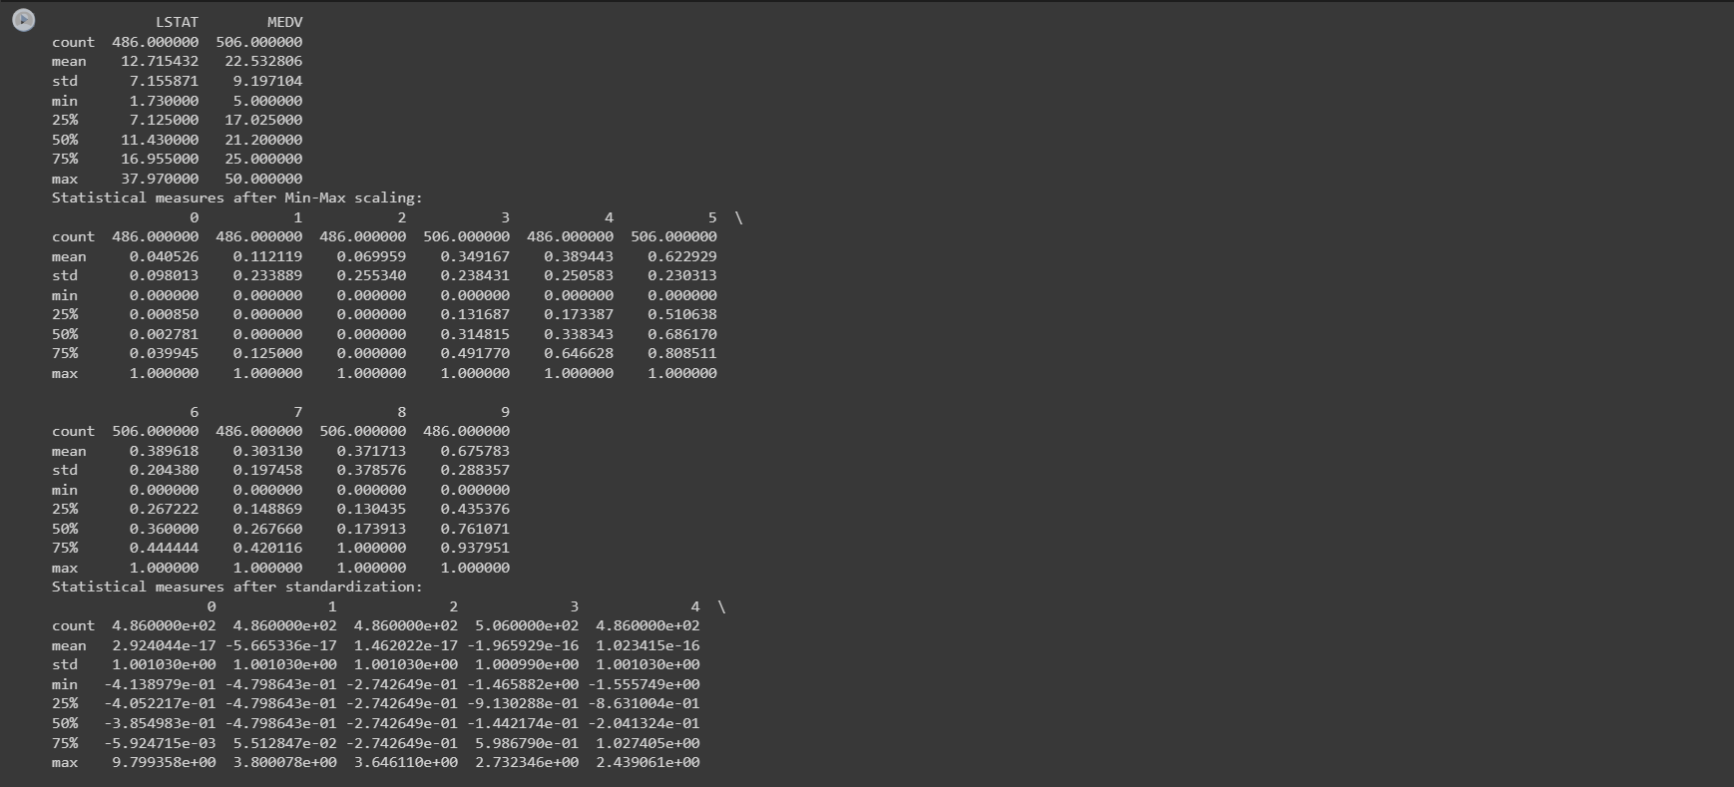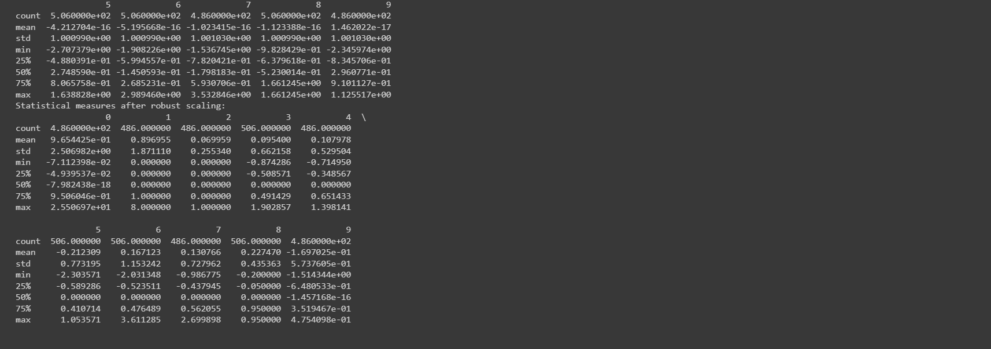

CODE:

# DURGAM NAGA DEERAJ REDDY(22BTRAD013)

print('Statistical measures before scaling:')

print(boston_data.describe())

# Statistical measures after Min-Max scaling

print('Statistical measures after Min-Max scaling:')

print(pd.DataFrame(boston_data_minmax).describe())

# Statistical measures after standardization

print('Statistical measures after standardization:')

print(pd.DataFrame(boston_data_std).describe())

# Statistical measures after robust scaling

print('Statistical measures after robust scaling:')

print(pd.DataFrame(boston_data_robust).describe())

GITHUB LINK:

https://github.com/DeeruReddy/Machine_learning